Unit-1
Operating System Overview
Overview of Computer Operating Systems:
- An operating system is a program that manages the computer hardware.
- It also provides a basis for application programs and acts as an intermediary between the computer user and the computer hardware.
What Operating Systems Do?
The operating system controls and coordinates the use of the hardware among the various application programs for the various users.
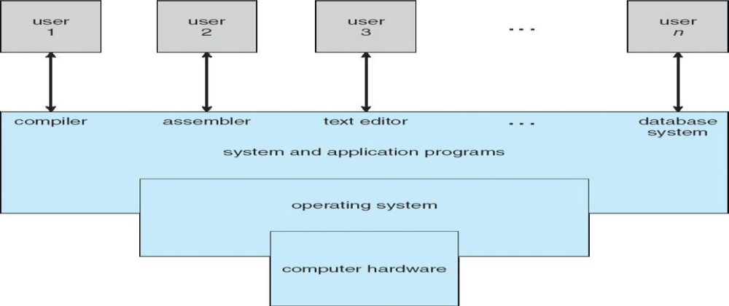
Abstact view of computer system
Userview:
- Program execution
- I/o operation
- Communications
- File system Manipulation
- Error Detection
System View:
- Resource Allowcation
- Accounting
- Protection and Security

Defining Operating Systems:
- OS is a resource allocator
- Manages all resources
- Decides between conflicting requests for efficient and fair resource use OS is a control program
- Controls execution of programs to prevent errors and improper use of thecomputer
Computer-System Organization
Computer-System Operation:
A modern general-purpose computer system consists of one or more CPUs and a number of device controllers connected through a common bus that provides access to shared memory.
Computer Startup
- bootstrap program is loaded at power-up or reboot
- Typically stored in ROM or EPROM, generally known as firmware
- Initializes all aspects of system
- Loads operating system kernel and starts execution

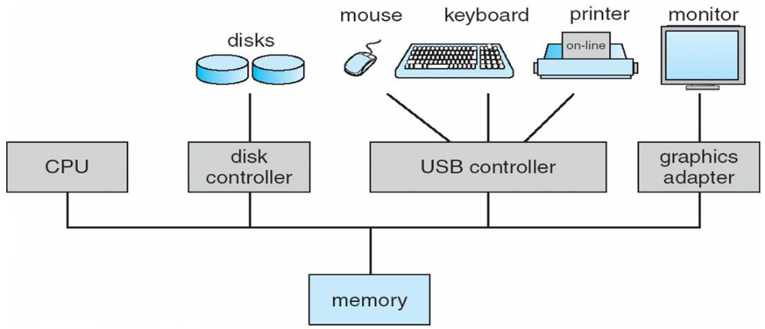
The occurrence of an event is usually signaled by an interrupt from either the hardware or the software. Software may trigger an interrupt by executing a special operation called a system call (also called a monitor call).
- I/O devices and the CPU can execute concurrently
- Each device controller is in charge of a particular device type
- Each device controller has a local buffer
- CPU moves data from/to main memory to/from local buffers
- I/O is from the device to local buffer of controller
- Device controller informs CPU that it has finished its operation by causing An interrupt

Common Functions of Interrupts
- Interrupt transfers control to the interrupt service routine generally, through the interrupt vector, which contains the addresses of all the service routines
- Interrupt architecture must save the address of the interrupted instruction
- Incoming interrupts are disabled while another interrupt is being processed to prevent a lost interruptnAtrap is a software-generated interrupt caused either by an error or a user request
- An operating system is interrupt driven

Interrupt Handling
- The operating system preserves the state of the CPU by storing registers and the program counter
- Determines which type of interrupt has occurred:
- Separate segments of code determine what action should be taken for each type of interrupt
Interrupt Timeline

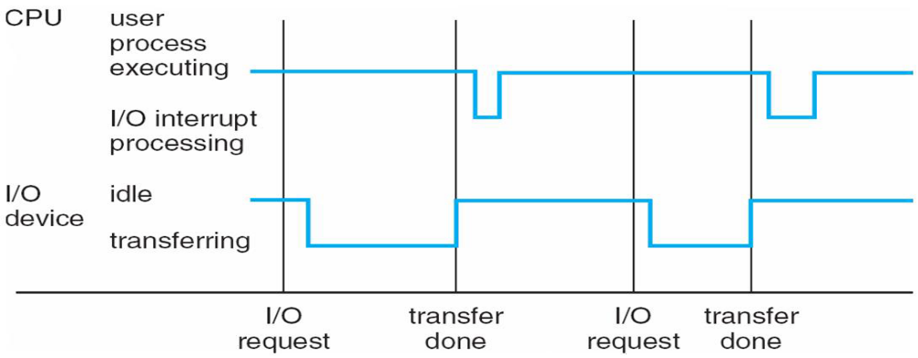
System call – request to the operating system to allow user to wait for I/O completion
Device-status table-contains entry for each I/O device indicating its type, address, and state
Operating system indexes into I/O device table to determine device status and to modify table entry to include interrupt

Operating System Structure
- Multiprogramming needed for efficiency
- Single user cannot keep CPU and I/O devices busy at all times
- Multiprogramming organizes jobs (code and data) so CPU always has one to Execute
- A subset of total jobs in system is kept in memory
- One job selected and run via job scheduling
- When it has to wait (for I/O for example), OS switches to another job
- Timesharing (multitasking) is logical extension in which CPU switches jobs so frequently that users can interact with each job while it is running, creating interactive computing
- Response time should be < 1 second
- Each user has at least one program executing in memory [process ]

Memory Layout for Multiprogrammed System
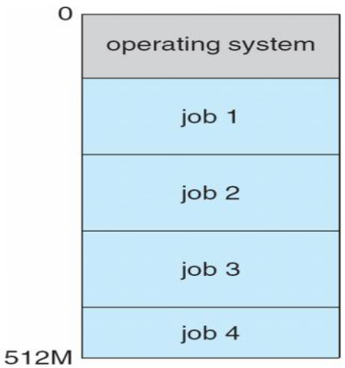
Operating-System Operations
- Interrupt driven by hardware
- Software error or request creates exception or trap
- Division by zero, request for operating system service
- Other process problems include infinite loop, processes modifying each Other or the operating system
- Dual-mode operation allows OS to protect itself and other system components
- User mode and kernel mode
- Mode bit provided by hardware
- Provides ability to distinguish when system is running user code or kernel code
- Some instructions designated as privileged, only executable in kernel mode
- System call changes mode to kernel, return from call resets it to user

Transition from User to Kernel Mode
- Timer to prevent infinite loop / process hogging resources
- Set interrupt after specific period
- Operating system decrements counter
- When counter zero generate an interrupt
- Set up before scheduling process to regain control or terminate program that exceeds allotted time
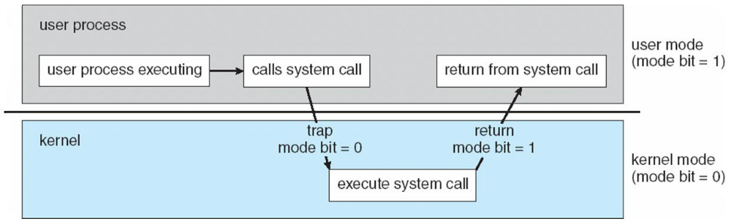
OPERATING SYSTEM FUNCTIONS

Process Management
- A process is a program in execution. It is a unit of work within the system. Program is a passive entity, process is an active entity.
- Process needs resources to accomplish its task
  - CPU, memory, I/O, files
- Initialization data
- Process termination requires reclaim of any reusable resources
- Single-threaded process has one program counter specifying location of next instruction to execute
- Process executes instructions sequentially, one at a time, until completion
- Multi-threaded process has one program counter per thread
- Typically system has many processes, some user, some operating system running concurrently on one or more CPUs
- Concurrency by multiplexing the CPUs among the processes / threads

Process Management Activities
- The operating system is responsible for the following activities in connection with process management:
- Creating and deleting both user and system processes
- Suspending and resuming processes
- Providing mechanisms for process synchronization
- Providing mechanisms for process communication
- Providing mechanisms for deadlock handling

Memory Management
- All data in memory before and after processing
- All instructions in memory in order to execute
- Memory management determines what is in memory when
- Optimizing CPU utilization and computer response to users

Memory management activities
- Keeping track of which parts of memory are currently being used and by whom
- Deciding which processes (or parts thereof) and data to move into and out of memory
- Allocating and deallocating memory space as needed

Storage Management
- OS provides uniform, logical view of information storage
- Abstracts physical properties to logical storage unit - file
- Each medium is controlled by device (i.e., disk drive, tape drive)
- Varying properties include access speed, capacity, data-transfer rate, access method (sequential or random)
- File-System management
- Files usually organized into directories
- Access control on most systems to determine who can access what

OS activities include
- Creating and deleting files and directories
- Primitives to manipulate files and dirs
- Mapping files onto secondary storage
- Backup files onto stable (non-volatile) storage media

Mass-Storage Management
- Usually disks used to store data that does not fit in main memory or data that must be kept for a “long” period of time
- Proper management is of central importance
- Entire speed of computer operation hinges on disk subsystem and its algorithms

MASS STORAGE activities
- Free-space management
- Storage allocation
- Disk scheduling
- Some storage need not be fast
- Tertiary storage includes optical storage, magnetic tape
- Still must be managed
- Varies between WORM (write-once, read-many-times) and RW (read-write)

Performance of Various Levels of Storage
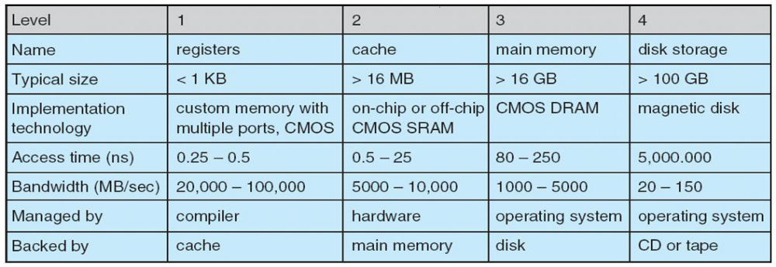
Migration of Integer A from Disk to Register
Multitasking environments must be careful to use most recent value, no matter where it is stored in the storage hierarchy
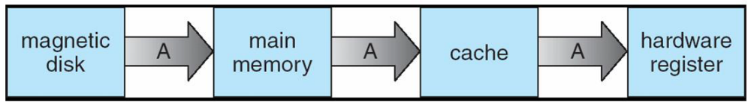
- Multiprocessor environment must provide cache coherency in hardware such that all CPUs have the most recent value in their cache
- Distributed environment situation even more complex
- Several copies of a datum can exist
I/O Subsystem
- One purpose of OS is to hide peculiarities of hardware devices from the user
- I/O subsystem responsible for
- Memory management of I/O including buffering (storing data temporarily while it is being transferred), caching (storing parts of data in faster storage for performance), spooling (the overlapping of output of one job with input of other jobs)
- General device-driver interface
- Drivers for specific hardware devices

Protection and Security
Protection – any mechanism for controlling access of processes or users to resources defined by the OS
Security – defense of the system against internal and external attacks
- Huge range, including denial-of-service, worms, viruses, identity theft, theft of service
- Systems generally first distinguish among users, to determine who can do what
- User identities (user IDs, security IDs) include name and associated number, one per user
- User ID then associated with all files, processes of that user to determine access control
- Group identifier (group ID) allows set of users to be defined and controls managed, then also associated with each process, file

DISTRIBUTED SYSTEMS
Computing Environments
Traditional computer
- Blurring over time
- Office environment

- PCs connected to a network, terminals attached to mainframe or minicomputers providing batch and timesharing
- Now portals allowing networked and remote systems access to same resources
- Home networks
- Used to be single system, then modems
- Now firewalled, networked
- Client-Server Computing
- Dumb terminals supplanted by smart PCs
- Many systems now servers, responding to requests generated by clients
- Compute-server provides an interface to client to request services (i.e. database)
- File-server provides interface for clients to store and retrieve files
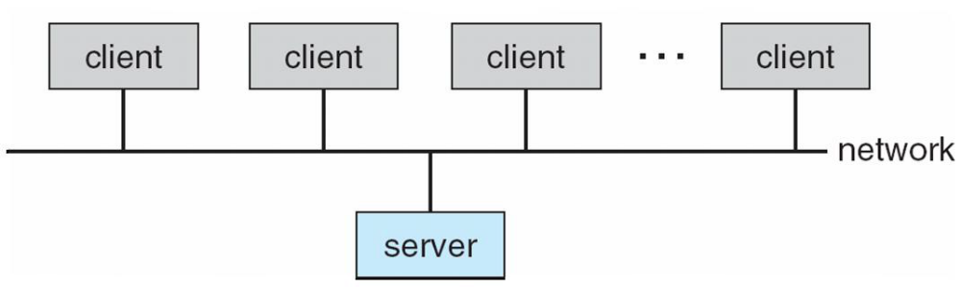
Peer-to-Peer Computing
- Another model of distributed system
- P2P does not distinguish clients and servers
- Instead all nodes are considered peers
- May each act as client, server or both
- Node must join P2P network
- Registers its service with central lookup service on network, or
- Broadcast request for service and respond to requests for service via discovery protocol
- Examples include Napster and Gnutella

Web-Based Computing
- Web has become ubiquitous
- PCs most prevalent devices
- More devices becoming networked to allow web access
- New category of devices to manage web traffic among similar servers: load balancers
- Use of operating systems like Windows 95, client-side, have evolved into Linux and Windows XP, which can be clients and servers

Open-Source Operating Systems
- Operating systems made avsyetailable in source-code format rather than just binary closed-source
- Counter to the copy protection and Digital Rights Management (DRM) movement
- Started by Free Software Foundation (FSF), which has “copyleft” GNU Public License (GPL)
- Examples include GNU/Linux, BSD UNIX (including core of Mac OS X), and Sun Solaris

Operating System Services
- One set of operating-system services provides functions that are helpful to the user:
- User interface - Almost all operating systems have a user interface (UI)
- Varies between Command-Line (CLI), Graphics User Interface (GUI), Batch
- Program execution - The system must be able to load a program into memory and to run that program, end execution, either normally or abnormally (indicating error)
- I/O operations - A running program may require I/O, which may involve a file or an I/O device

- File-system manipulation - The file system is of particular interest. Obviously, programs need to read and write files and directories, create and delete them, search them, list file Information, permission management.

A View of Operating System Services
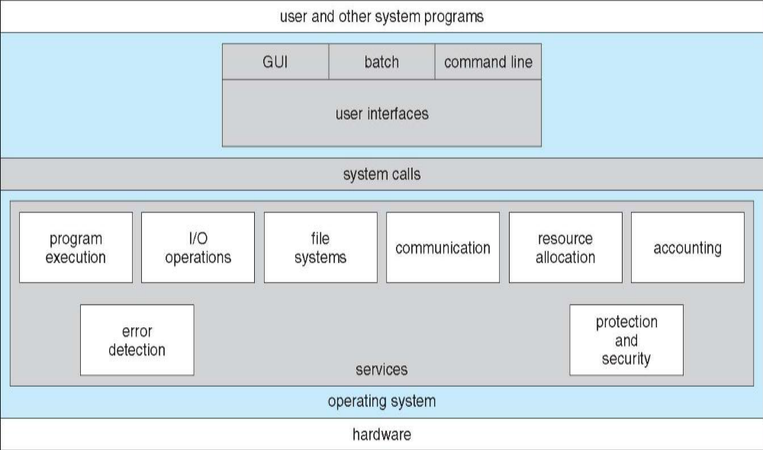

Operating System Services
- One set of operating-system services provides functions that are helpful to the user
- Communications – Processes may exchange information, on the same computer or between computers
- over a network Communications may be via shared memory or through message passing (packets moved by the OS)
- Error detection – OS needs to be constantly aware of possible errors May occur in the CPU and memory
- hardware, in I/O devices, in user program For each type of error, OS should take the appropriate action
- to ensure correct and consistent computing Debugging facilities can greatly enhance the user’s and
- programmer’s abilities to efficiently use the system
- Another set of OS functions exists for ensuring the efficient operation of the system itself via resource sharing
Resource allocation - When multiple users or multiple jobs running concurrently, resources must be allocated to each of them
Many types of resources - Some (such as CPU cycles, main memory, and file storage) may have special allocation code, others (such as I/O devices) may have general request and release code
Accounting - To keep track of which users use how much and what kinds of computer resources
Protection and security - The owners of information stored in a multiuser or networked computer system may want to control use of that information, concurrent processes should not interfere with each other
Protection-involves ensuring that all access to system resources is controlled
Security-of the system from outsiders requires user authentication, extends to defending external I/O devices from invalid access attempts
If a system is to be protected and secure, precautions must be instituted throughout it. A chain is only as strong as its weakest link.

User Operating System Interface - CLI
- Command Line Interface (CLI) or command interpreter allows direct command entry
- Sometimes implemented in kernel, sometimes by systems program
- Sometimes multiple flavors implemented – shells
- Primarily fetches a command from user and executes it
- Sometimes commands built-in, sometimes just names of programs
- If the latter, adding new features doesn’t require shell modification
User Operating System Interface - GUI
- User-friendly desktop metaphor interface
- Usually mouse, keyboard, and monitor
- Icons represent files, programs, actions, etc
- Various mouse buttons over objects in the interface cause various actions (provide information, options, execute function, open directory (known as a folder)
- Invented at Xerox PARC
- Many systems now include both CLI and GUI interfaces
- Microsoft Windows is GUI with CLI “command” shell
System Calls
System calls are the fundamental interface between an operating system and the user-level processes or applications running on a computer system. They provide a way for programs to request services from the operating system, such as accessing hardware devices, managing files, communicating with other processes, and performing various system-related tasks.
- Programming interface to the services provided by the OS
- Typically written in a high-level language (C or C++)
- Mostly accessed by programs via a high-level Application Program Interface (API) rather than direct system call usenThree most common APIs are Win32 API for Windows, POSIX API for POSIX-based systems (including virtually all versions of UNIX, Linux, and Mac OS X), and Java API for the Java virtual machine (JVM)
- Why use APIs rather than system calls?(Note that the system-call names used throughout this text are generic)

Example of System Calls
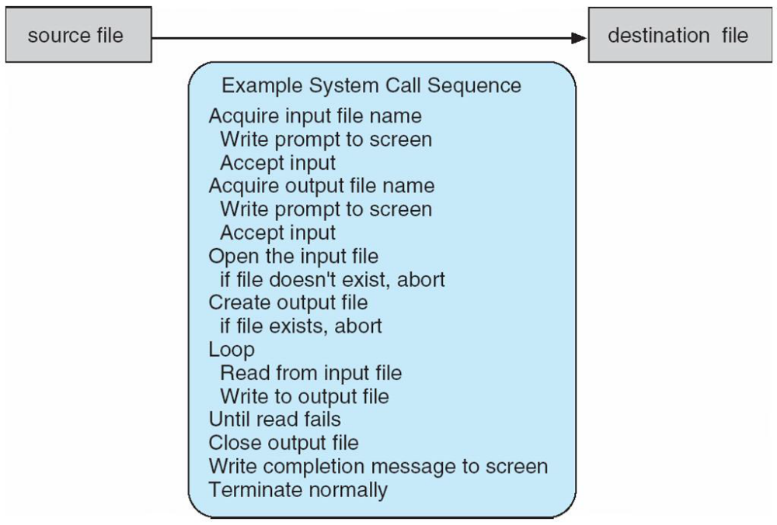
System Call Implementation
- Typically, a number associated with each system call
- System-call interface maintains a table indexed according to these
- Numbers
- The system call interface invokes intended system call in OS kernel and returns status of the system call and any return values
- The caller need know nothing about how the system call is implemented
- Just needs to obey API and understand what OS will do as a result call
- Most details of OS interface hidden from programmer by API
- Managed by run-time support library (set of functions built into libraries included with compiler)
API – System Call – OS Relationship
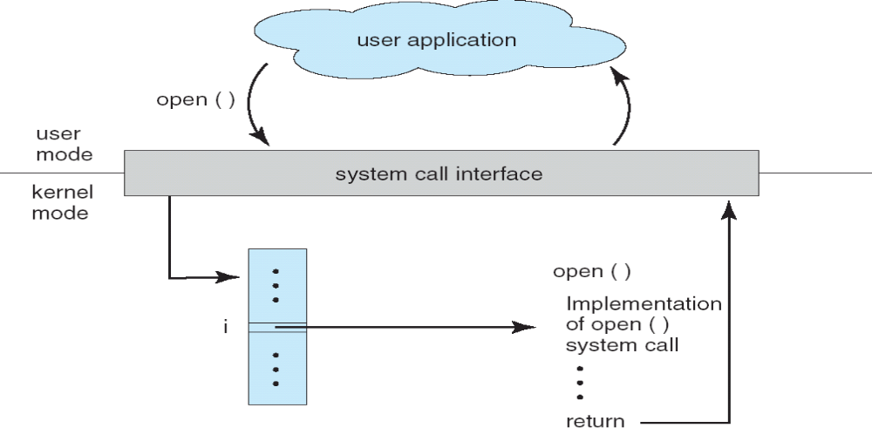
System Call Parameter Passing
- Often, more information is required than simply identity of desired system call
- Exact type and amount of information vary according to OS and call
- Three general methods used to pass parameters to the OS
- Simplest: pass the parameters in registers
- In some cases, may be more parameters than registers
- Parameters stored in a block, or table, in memory, and address of block passed as a parameter in a register
- This approach taken by Linux and Solaris
- Parameters placed, or pushed, onto the stack by the program and popped off the stack by the operating system
- Block and stack methods do not limit the number or length of parameters being passed

Parameter Passing via Table
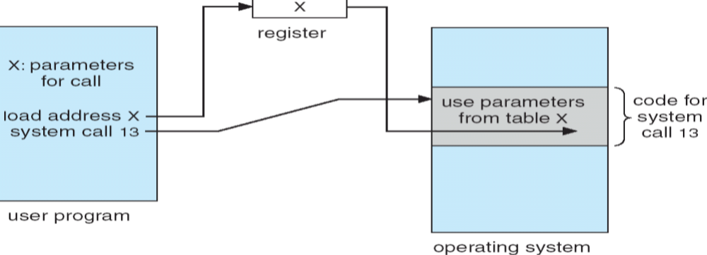

Types of System Calls

Process control
- end, abort
- load, execute
- create process, terminate process
- get process attributes,set process attributes
- wait for time
- wait event, signal event
- allocate and free memory
File management
- create file, delete file
- open, close
- read, write, reposition
- get file attributes, set file attributes
Device managementDXX
- create file, delete file
- open, close
- read, write, reposition
- get file attributes, set file attributes
Information maintenance
- get time or date, set time or date
- get system data, set system data
- get process, file, or device attributes
- set process, file, or device attributes
Communications
- create, delete communication connection
- send, receive messages
- transfer status information
- attach or detach remote devices
Protection
- controlled access to resources
- get/set permission
- allow/deny access to users

Layered Approach

The operating system is divided into a number of layers (levels), each built on top of lower layers. The bottom layer (layer 0), is the hardware; the highest (layer N) is the user interface. With modularity, layers are selected such that each uses functions (operations) and services of only lower-level layers
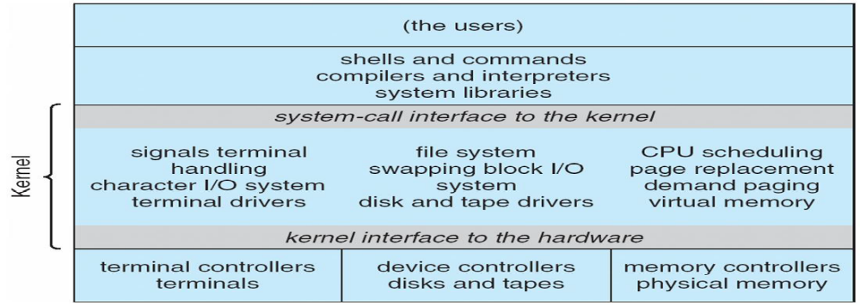
Layered Operating System
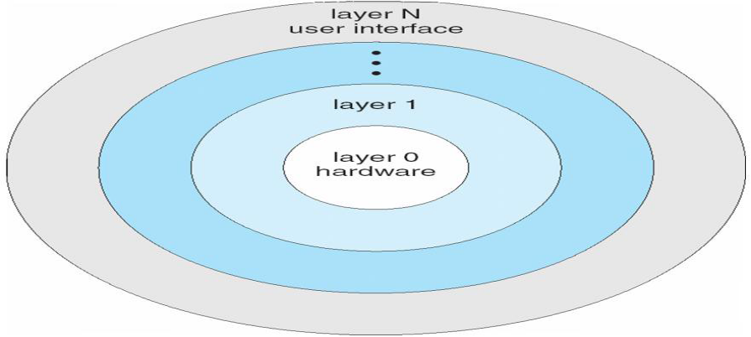
Micro kernel System Structure
- Moves as much from the kernel into “user” space
- Communication takes place between user modules using message passing
- Benefits:
- Easier to extend a microkernel
- Easier to port the operating system to new architectures
- More reliable (less code is running in kernel mode)
- More secure
Operating System Generation
- Operating systems are designed to run on any of a class of machines; the system must be configured for each specific computer site
- SYSGEN program obtains information concerning the specific configuration of the hardware system
- Booting – starting a computer by loading the kernel
- Bootstrap program – code stored in ROM that is able to locate the kernel, load it into memory, and start its execution
System Boot
- Operating system must be made available to hardware so hardware can start it
- Small piece of code – bootstrap loader, locates the kernel, loads it into memory, and starts it
- Sometimes two-step process where boot block at fixed location loads bootstrap loader .When power initialized on system, execution starts at a fixed memory location Firmware used to hold initial boot code

